The Lord’s Prayer

⁹ After this manner therefore pray ye:
Our Father which art in heaven, Hallowed
be thy name.
¹⁰ Thy kingdom come, Thy will be done
in earth, as it is in heaven.
¹¹ Give us this day our daily bread.
¹² And forgive us our debts, as we
forgive our debtors.
¹³ And lead us not into temptation,
but deliver us from evil: For thine is
the kingdom, and the power, and
the glory, forever. Amen.

–Matthew 6:9-13

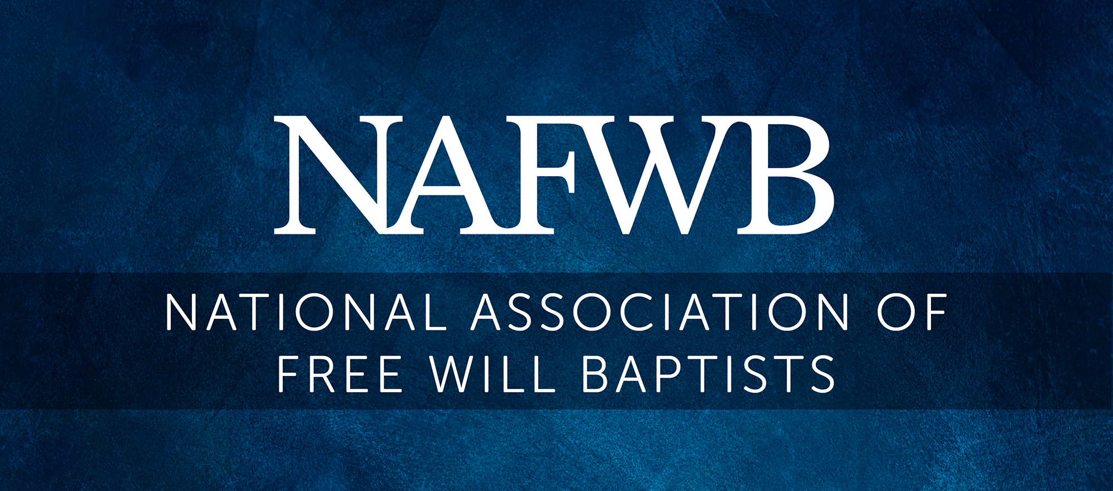

“Pray without ceasing.”

–1 Thessalonians 5:17

MY PRAYER JOURNAL

________________________________________

Name

________________________________________
Date

The Free Will Baptist Church Covenant

Having given ourselves to God, by faith in Christ, and adopted the Word of God as our rule of faith and practice, we now give ourselves to one another by the will of God in this solemn covenant.

We promise, by His grace, to love and obey Him in all things, to avoid all appearance of evil, to abstain from all sinful amusements and unholy conformity to the world, from all sanction of the use and sale of intoxicating beverages, and to “provide things honest in the sight of all men.”

We agree faithfully to discharge our obligations in reference to the study of the Scriptures, secret prayer, family devotions, and social worship; and by self-denial, faith, and good works endeavor to “grow in grace and the knowledge of our Lord and Savior Jesus Christ.”

We will not forsake the assembling of ourselves together for church conferences, public worship, and the observance of the ordinances of the Gospel; nor fail to pay according to our ability for the support of the church, of its poor, and all its benevolent work.

We agree to accept Christian admonition and reproof with meekness, and to watch over one another in love, endeavoring to “keep the unity of the Spirit” in the bonds of peace, to be careful of one another’s happiness and reputation, and seek to strengthen the weak, encourage the afflicted, admonish the erring, and as far as we are able, promote the success of the church and of the Gospel.

We will everywhere hold Christian principle sacred and Christian obligations and enterprises supreme; counting it our chief business in life to extend the influence of Christ in society, constantly praying and toiling that the kingdom of God may come, and His will be done on earth as it is in heaven.

To this end we agree to labor for the promotion of educational and denominational enterprises, the support of missions, the success of Sunday schools, and evangelistic efforts for the salvation of the world. And may the God of peace sanctify us wholly, and preserve us blameless unto the coming of our Lord Jesus Christ.

The Free Will Baptist Logo
The logo of the Free Will Baptists incorporates four symbols used by the earliest communities in Christendom: the ship, the fish, the anchor, and the cross. In the four corners of the ship’s sail, the symbols of earliest Christianity are enhanced by modern emblems of a vital, living faith—the Holy Bible, the Loaf and Cup, the Basin and Towel and Clasped Hands —the symbols of Free Will Baptists.
The Ship symbolizes the Church and represents all the members pulling in one direction, guided and empowered by the Holy Spirit. Seeking to fulfill Christ’s last command to


The Free Will Baptist logo incorporates four symbols used by the earliest communities in Christendom: the ship, the fish, the anchor, and the cross. In the four corners of the ship’s sail, the symbols of earliest Christianity are enhanced by modern emblems of a vital, living faith—the Holy Bible, the Loaf and Cup, the Basin and Towel, and Clasped Hands—the symbols of Free Will Baptists. The Ship symbolizes the Church and represents all members pulling one direction, guided and empowered by the Holy Spirit. Seeking to fulfill Christ’s last command to the Church, Free Will Baptists unite in one purpose with one priority to proclaim the good news of the gospel throughout the world.
The Fish, represented in the symbol by the space between the bottom of the sail and the top of the ship’s body, is one of the most popular symbols for Jesus Christ. Many believe that it was a secret symbol which identified Christians during periods of persecution. The word “fish” in the first century Greek (ichthus) is an acrostic for Jesus Christ, Son of God, Savior. The Anchor on the bow of the ship symbolizes the Christian hope of salvation, “the sure, strong and steadfast anchor of the soul.”
The Cross forms the emblem in the mast of the ship. It is the most familiar symbol in the history of the world. The Cross, an instrument of execution and death turned into a worldwide emblem of hope and love by the death and resurrection of Jesus Christ. The Bible has always been at the heart of our life as Free Will Baptists, the centrality of the scriptures. Free Will Baptists adopt the Word of God as our only rule of faith and practice. We believe the scriptures to be inspired, inerrant, infallible and immutable.
The Loaf and Cup represent the Lord’s supper, one of the gospel ordinances. This ordinance commemorates the death of Christ for our sins in the use of the bread which He made the emblem of His broken body and the cup the emblem of His shed blood. Participation in this ordinance expresses love for Christ, faith and hope in Him, and serves as a pledge of perpetual fidelity and faithfulness to Him. The Basin and Towel historically symbolize the service and outreach of the church, but for us it has an added significance of representing our practice of washing the saints’ feet.
The Clasped Hands symbolize many things to us: fellowship, brotherhood and the warmth of our faith. Perhaps the most important thing symbolized by the clasped hands is our commitment to reach out to people around the world with the good news.

“For the kingdom is the Lord's: and he is the
governor among the nations.”

–Psalm 22:28

2025 Upcoming Events

Welch College Fund Offering February 23
Forum25 Conference March 9-11
D6 Conference Northwest March 21-22
Easter April 20
D6 Conference Southeast April 22-24
Rest of the Family Offering April 27
Mother’s Day May 11
Father’s Day June 15
Independence Day July 4
FWB National Convention July 20-23
World Missions Offering August 31
Mission North America Offering November 23
Thanksgiving Day November 27
Leadership Conference December 8-9
Christmas Day December 25

Adoration

“Our Father which art in heaven, Hallowed be thy name.”
–Matthew 6:9b

“O come, let us worship and bow down: let us
kneel before the Lord our maker.”
–Psalm 95:6

As you read your Bible, record some of the characteristics of God and praise Him for who He is.

Monday

__________________ __________________

Tuesday

__________________ __________________

Wednesday

__________________ __________________

Thursday

__________________ __________________

Friday

__________________ __________________

Confession

“Search me, O God, and know my heart: try me, and know my thoughts: And see if there be any wicked way in me, and lead me in the way everlasting.”
–Psalm 139:23-24

“And forgive us our debts, as we forgive our debtors.”
–Matthew 6:12

Monday

__________________ __________________

Tuesday

__________________ __________________

Wednesday

__________________ __________________

Thursday

__________________ __________________

Friday

__________________ __________________

For All

“I exhort therefore, that, first of all, supplications, prayers, intercessions, and giving of thanks, be made for all men;
For kings, and for all that are in authority; that we may lead a quiet and peaceable life in all godliness and honesty.”

–1 Timothy 2:1-2

Monday—Pastor(s) and families

______________________________________________

______________________________________________

Tuesday—Other church leaders and teachers

______________________________________________

______________________________________________

Wednesday—Federal Government Leaders

______________________________________________

______________________________________________

Thursday—State Government Leaders

______________________________________________

______________________________________________

Friday—Local Government Leaders

______________________________________________

______________________________________________

For Those With Broken Hearts

“The Lord is nigh unto them that are of a broken heart;
and saveth such as be of a contrite spirit.”
–Psalm 34:18

Monday

______________________________________________

______________________________________________

Tuesday

______________________________________________

______________________________________________

Wednesday

______________________________________________

______________________________________________

Thursday

______________________________________________

______________________________________________

Friday
______________________________________________

______________________________________________

Thanksgiving

“In everything give thanks: for this is the will of God in Christ Jesus concerning you.”
–1 Thessalonians 5:18

Monday

__________________ __________________

__________________ __________________

Tuesday

__________________ __________________

__________________ __________________

Wednesday

__________________ __________________

__________________ __________________

Thursday

__________________ __________________

__________________ __________________

Friday

__________________ __________________

__________________ __________________

Supplication

“Be careful for nothing; but in everything by prayer
and supplication with thanksgiving let your requests
be made known unto God.”
–Philippians 4:6

For Me

“Thy kingdom come, Thy will be done in earth,
as it is in heaven.”
–Matthew 6:10

Monday

__________________ __________________

Tuesday

__________________ __________________

Wednesday

__________________ __________________

Thursday

__________________ __________________

Friday

__________________ __________________

For My Church

“As we have therefore opportunity, let us do good
unto all men, especially unto them who are
of the household of faith.”
–Galatians 6:10

Monday

______________________________________________

______________________________________________

Tuesday

______________________________________________

______________________________________________

Wednesday

______________________________________________

______________________________________________

Thursday

______________________________________________

______________________________________________

Friday

______________________________________________

______________________________________________

For My Family

“And thou shalt teach them diligently unto thy children, and shalt talk of them when thou sittest in thine house, and when thou walkest by the way, and when thou liest down, and when thou risest up.”
–Deuteronomy 6:7

Monday

______________________________________________

______________________________________________

Tuesday

______________________________________________

______________________________________________

Wednesday

______________________________________________

______________________________________________

Thursday

______________________________________________

______________________________________________

Friday

______________________________________________

______________________________________________

For the Sick

“Is any among you afflicted? Let him pray. Is
any merry? Let him sing psalms.”
–James 5:13

Monday

______________________________________________

______________________________________________

Tuesday

______________________________________________

______________________________________________

Wednesday

______________________________________________

______________________________________________

Thursday

______________________________________________

______________________________________________

Friday

______________________________________________

______________________________________________

Our Missionaries

Monday

______________________________________________

______________________________________________

Tuesday

______________________________________________

______________________________________________

Wednesday

______________________________________________

______________________________________________

Thursday

______________________________________________

______________________________________________

Friday

______________________________________________

______________________________________________

Go to IMINC.org and FWBNAM.com for the latest

on missionaries and church planters.

For Those to Whom I Am Witnessing or Discipling

“Go ye therefore, and teach all nations, baptizing
them in the name of the Father, and of the Son,
and of the Holy Ghost.”
–Matthew 28:19

Monday

______________________________________________

______________________________________________

Tuesday

______________________________________________

______________________________________________

Wednesday

______________________________________________

______________________________________________

Thursday

______________________________________________

______________________________________________

Friday

______________________________________________

______________________________________________

